1 | Principio del formulario
  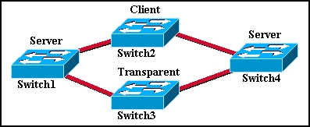
  Refer to the exhibit. The switches in the exhibit are connected with trunks within the same VTP management domain. Each switch is labeled with its VTP mode. A new VLAN is added to Switch3. This VLAN does not show up on the other switches. What is the reason for this?
   | VLANs cannot be created on transparent mode switches.
   | Server mode switches neither listen to nor forward VTP messages from transparent mode switches.
   | VLANs created on transparent mode switches are not included in VTP advertisements.
   | There are no ports assigned to the new VLAN on the other switches.
   | Transparent mode switches do not forward VTP advertisements.
2 | Principio del formulario
  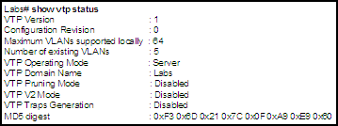
  Refer to the exhibit. Which two facts can be confirmed by this output? (Choose two.)
   | If this switch is added to an established network, the other VTP-enabled switches in the same VTP domain will consider their own VLAN information to be more recent than the VLAN information advertised by this switch.
   | This switch shows no configuration revision errors.
   | This switch has established two-way communication with the neighboring devices.
   | This switch is configured to advertise its VLAN configuration to other VTP-enabled switches in the same VTP domain.
   | This switch is configured to allows the network manager to maximize bandwidth by restricting traffic to specific network devices.

3 | Principio del formulario
  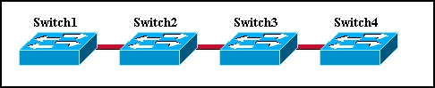
  Refer to the exhibit. Switch1 is not participating in the VTP management process with the other switches shown in the exhibit. What are two possible reasons for this? (Choose two.)
  Switch2 is in transparent mode.
  Switch1 is in client mode.
  Switch1 is using VTP version 1 and Switch2 is using VTP version 2.
  Switch2 is in server mode.
  Switch1 is in a different management domain.
  Switch1 has no VLANs.
4 | Principio del formulario
  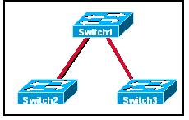
  Refer to the exhibit. Switch2 was previously used in a lab environment and has been added to the production network in server mode. The lab and production networks use the same VTP domain name, so the network administrator made no configuration changes to Switch2 before adding it to the production network. The lab domain has a higher revision number. After Switch2 was added to the production network, many computers lost network connectivity. What is the quickest way to solve the problem?
  Reset the revision number on Switch2 with either the delete VTP command or by changing the domain name and then changing it back.
  Change Switch1 to transparent VTP mode to reclaim all VLANs in vlan.dat, and then change back to server mode.
  Change Switch2 to client mode so the VLANs will automatically repopulate.
  Re-enter all appropriate VLANs, except VLAN 1, manually on Switch1 so that they repropagate throughout the network.

5 | Principio del formulario
  Which statement is true about the VTP pruning process?
  VTP pruning automatically updates all switches within the VTP domain with VLAN information.
  VTP pruning updates all switches within the VTP domain with information about pruning-eligible VLANs.
  VTP pruning updates all switches within the VTP domain with information about pruning-ineligible VLANs.
  VTP pruning prevents flooded traffic from crossing trunk links to switches that do not need to process the flood traffic.
6 | Principio del formulario
  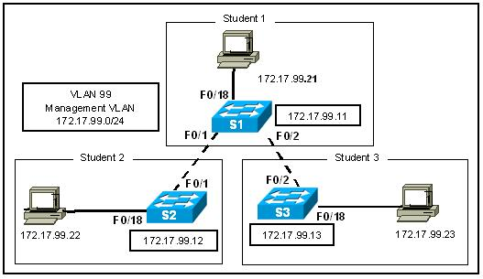
  Refer to the exhibit. Switch S1 is in VTP server mode. Switches S2 and S3 are in client mode. An administrator accidentally disconnects the cable from F0/1 on S2. What will the effect be?
  S2 loses all VLANs until the cable is reconnected.
  S2 automatically transitions to VTP transparent mode.
  S2 does not send a VTP request advertisement unless it is reloaded.
  S2 automatically sends a VTP request advertisement to 172.17.99.11 when the cable is reconnected.

7 | Principio del formulario
  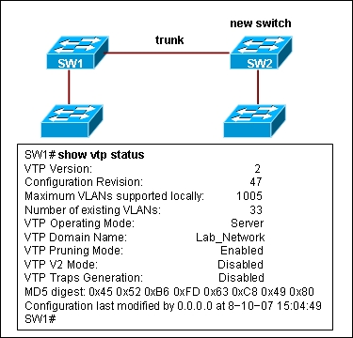
  Refer to the exhibit. All switches in the network participate in the same VTP domain. What happens when the new switch SW2 with a default configuration and revision number of 0 is inserted in the existing VTP domain Lab_Network?
  The switch operates as a VTP client.
  The switch operates in VTP transparent mode.
  The switch operates as a VTP server and deletes the existing VLAN configuration in the domain.
  The switch operates as a VTP server, but does not impact the existing VLAN configuration in the domain.
8 | Principio del formulario
  What does a client mode switch in a VTP management domain do when it receives a summary advertisement with a revision number higher than its current revision number?
  It suspends forwarding until a subset advertisement update arrives.
  It issues an advertisement request for new VLAN information.
  It increments the revision number and forwards it to other switches.
  It deletes the VLANs not included in the summary advertisement.
  It issues summary advertisements to advise other switches of status changes.

9 | Principio del formulario
  Which statement is true when VTP is configured on a switched network that incorporates VLANs?
  VTP is only compatible with the 802.1Q standard.
  VTP adds to the complexity of managing a switched network.
  A switch configured for VTP can belong to more than one VTP domain.
  VTP dynamically communicates VLAN additions, deletions and modifications to all switches in the same VTP domain.
  VTP advertisements are passed over access links to other switches.
10 | Principio del formulario
  Which two statements describe VTP client mode operation. (Choose two.)
  can add VLANs of local significance only
  can only adopt VLAN management changes
  can create and adopt updated VLAN management information
  can only pass VLAN management information without adopting changes
  can add VLANs to domain
  cannot add VLANs

11 | Principio del formulario
  What causes a VTP configured switch to issue a summary advertisement?
  A new host has been attached to a switch in the management domain.
  A port on a switch in the management domain has changed to blocking mode.
  A five-minute update timer has elapsed.
  The advertisement revision number has reached n+1.
12 | Principio del formulario
  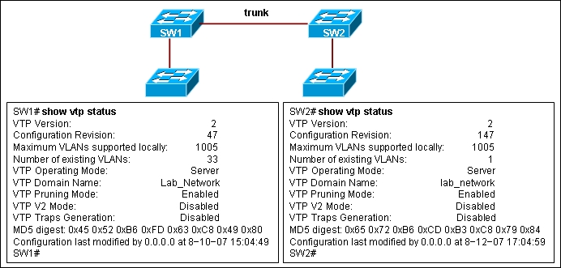
  Refer to the exhibit. Switches SW1 and SW2 are interconnected via a trunk link but failed to exchange VLAN information. The network administrator issued the show vtp status command to troubleshoot the problem. On the basis of the output provided, what could be done to fix the problem?
  The switches must be interconnected via access link.
  Switch SW2 must be configured as a VTP client.
  Both switches must be configured as VTP clients.
  Both switches must be configured with the same VTP revision number.
  The switches must be configured with the same VTP domain name.

13 | Principio del formulario
  Which two statements describe VTP transparent mode operation? (Choose two.)
  Transparent mode switches can create VLAN management information.
  Transparent mode switches can add VLANs of local significance only.
  Transparent mode switches pass any VLAN management information that they receive to other switches.
  Transparent mode switches can adopt VLAN management changes that are received from other switches.
  Transparent mode switches originate updates about the status of their VLANS and inform other switches about that status.
14 | Principio del formulario
  Which two statements are true about the implementation of VTP? (Choose two.)
  Switches must be connected via trunks.
  The VTP domain name is case sensitive.
  Transparent mode switches cannot be configured with new VLANs.
  The VTP password is mandatory and case sensitive.
  Switches that use VTP must have the same switch name.

15 | Principio del formulario
  Which three VTP parameters must be identical on all switches to participate in the same VTP domain? (Choose three.)
  revision number
  domain name
  pruning
  mode
  domain password
  version number
16 | Principio del formulario
  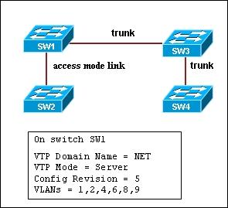
  Refer to the exhibit. All switches in the VTP domain are new. Switch SW1 is configured as a VTP server, switches SW2 and SW4 are configured as VTP clients, and switch SW3 is configured in VTP transparent mode. Which switch or switches receive VTP updates and synchronize their VLAN configuration based on those updates?
  All switches receive updates and synchronize VLAN information.
  Only switch SW2 receives updates and synchronizes VLAN information.
  SW3 and SW4 receive updates, but only switch SW4 synchronizes VLAN information.
  Only switches SW3 and SW4 receive updates and synchronize VLAN information.
17 | Principio del formulario
  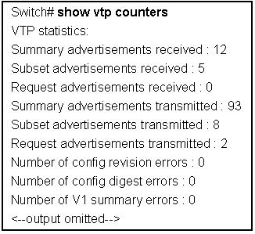
  Refer to the exhibit. What information can be learned from the output provided?
  It verifies the configured VTP password.
  It verifies the VTP domain is configured to use VTP version 2.
  It verifies VTP advertisements are being exchanged.
  It verifies the VTP domain name is V1.

